Software Requirements Specification
for
Game of Chess

Prepared by Condor Army

02/02/2018
Table of Contents
Table of Contents ii
Revision History ii
1. Introduction 1
1.1 Purpose 1
1.2 Intended Audience and Reading Suggestions 1
1.3 Product Scope 1
1.4 Definitions……………………………………………………………………..………………..…1

2. Overall Description 1
2.1 Product Perspective 1
2.2 Product Functions 2
2.3 User Classes and Characteristics 2
2.4 Assumptions and Dependencies 2
3. External Interface Requirements 2
3.1 User Interfaces 2
3.2 Hardware Interfaces 4
4. System Features 4
4.1 System Start Menu 4
4.2 User Movement 5
4.3 Core Game Screen 6

Revision History
Name | Date | Reason For Changes | Version

Introduction

Purpose
This document shall capture all the functional requirements needed to implement a game of chess. It will illustrate constraints, design, and an implementation of a user interface.

Intended Audience and Reading Suggestions
This document is intended towards our customer (Jason Diaz), documentation writers, testers, and developers of the game.

Product Scope
This program shall use a user interface to allow a user to engage in a real time game of chess against the computer. This game shall begin from the normal starting position and complete when check mate has been determined. This program shall also include bonus features including sound effects, highlighting movement options, random move generator in which the game will make the move for the player, and the ability to choose a board and piece color of the player’s choice.

Definitions
Move timer- a countdown timer showing how much time the user must move.

User – Someone who interacts with the chess game application.

Overall Description

Product Perspective
Because this is a basic implementation of a chess program, it will be very similar to most chess programs and Apps found online.

Product Functions
- Allow for user input
- Include sound effect
- Highlighting movement options
- Random move maker
- Board Color choice
- Piece Color Choice

User Classes and Characteristics
This chess program is intended for users of all ages who have a basic understanding of chess and its rules.

Assumptions and Dependencies
This program can be played in any system that can run Unity 2017.3

External Interface Requirements

User Interfaces
The software shall present the user with a main menu with options to play, change the settings, or quit the game.

Figure 1: Shows the system start menu which shall allow the user to make desired settings as well as begging and exiting the game.
Figure 2: Shows User setting whish shall allow the user to personalize the game.
Figure 3: Shows the screen that users will see when playing the game.

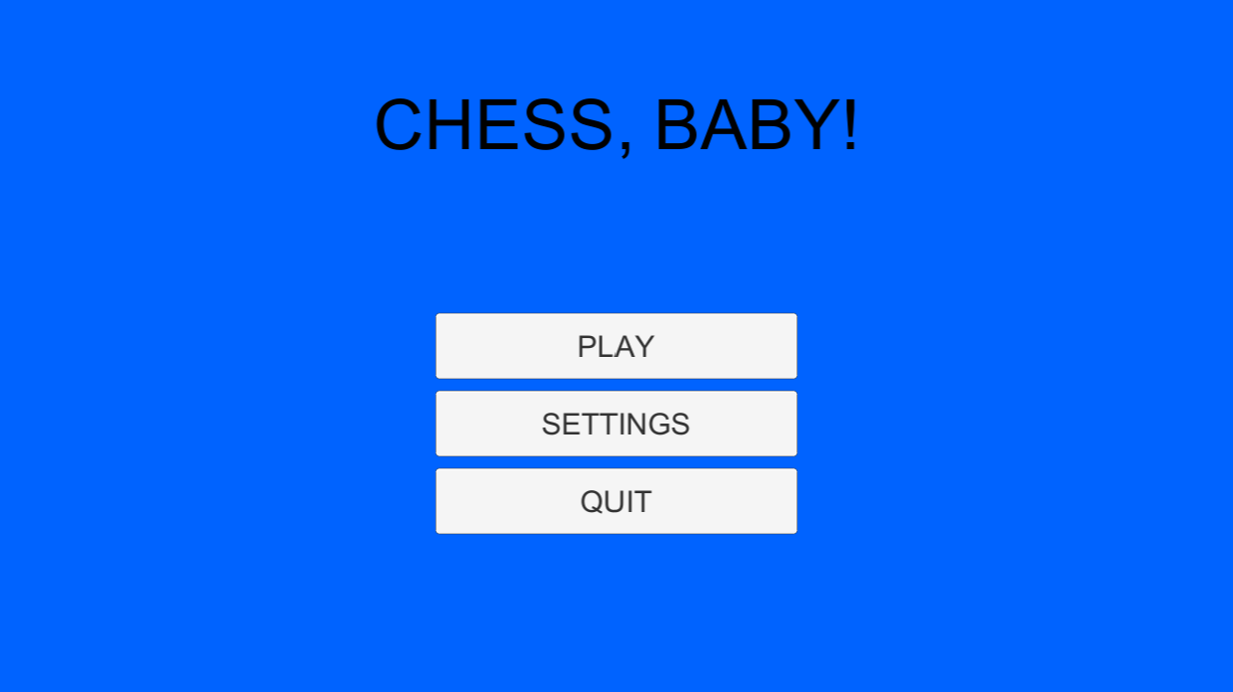

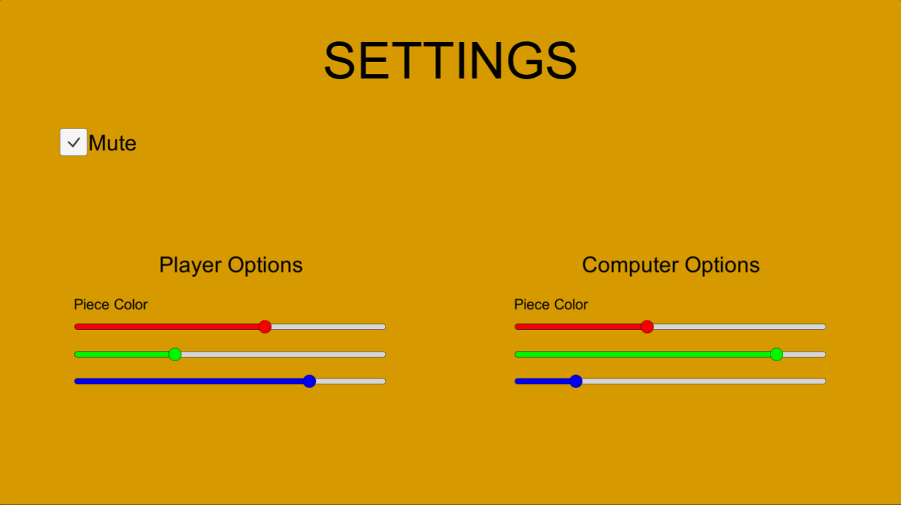
Figure 1: System Start menu

Timer

Figure 2: User settings

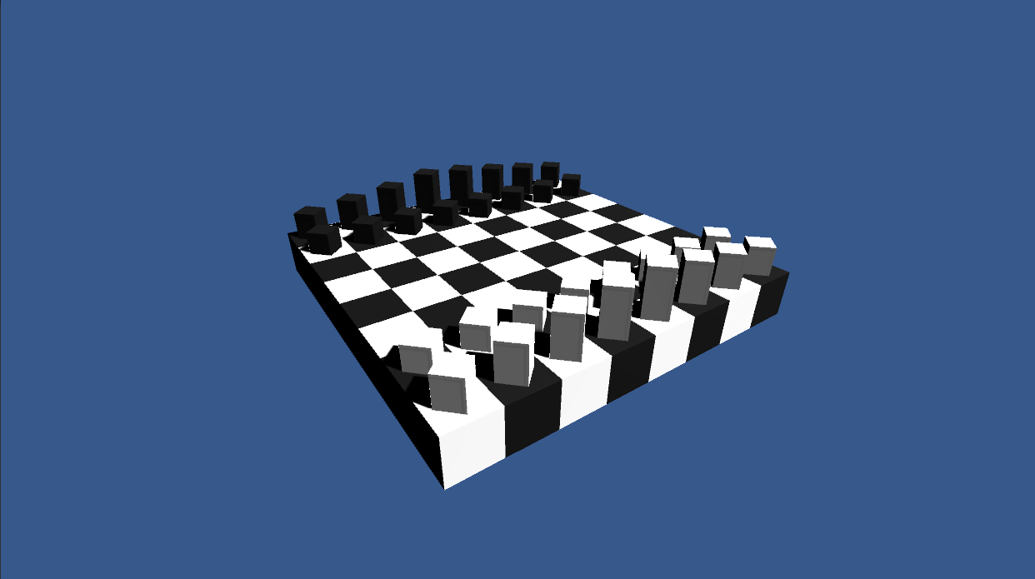
Time left: 20:00
Random Move

Figure 3: Game Screen

Hardware Interfaces
The system shall accept inputs from no fewer devices than a keyboard and mouse.

System Features

System Start menu

Description

When the application is executed, the user is presented with a start screen. The screen will allow the user to choose the settings icon and choose the board and piece color for the user and computer, as well as deciding who will goes first. If they want to move timer they should be able to decide the amount of time or default to 20 min. If no user input is given towards the settings, the start screen will default to the user going first as well as the user being white and the computer being black, the board being white and black, timer being disabled. After the user has given their desired settings, they may click the start button to game screen.

Stimulus/Response Sequences
Step 1: Launch Chess Game application in windows
Step 2: User makes selections and desired settings
Step 3: User Clicks start and begins the game

Functional Requirements

REQ-1: The system shall allow the user to choose the color of their own pieces and of the computers.
REQ-2: The system shall allow the user to choose the color of board.
REQ-3: The system shall allow the user to choose between who will go first or if the selection is random.
REQ-4: The system shall allow the user to disable/enable to move timer.
REQ-5: If the timer is enabled, the system shall allow the user to input desired time.
REQ-6: System will default the start screen to have the user play first and to be white, the computer to be black with a disabled timer, and the board to be black and white.
REQ-7: The system shall allow the user to start the game at any time.

User Movement

Description and Priority
Once it is the users turn to move, the user will be able to select any of their pieces at which point any possible moves will be highlighted on the board. The user will be able to choose from these highlighted spaces at which point the piece will move from its current position to the selected position, making a sound in the process and ending the users turn. They user may instead choose the random move option which randomly moves one piece to a random legal available position. If the user does not make a valid move before the move timer runs out, the users turn will automatically end and it will become the computers turn.

Stimulus/Response Sequences
Step 1: The timer will start the countdown from the desired time if enabled.
Step 2: The user will be able to select a piece of their own.
Step 3: The system will highlight any valid available positions.
Step 4: The user can choose a highlighted position to move that piece to or can choose a different piece going back to step 3.
Step 5: If the user does not want to make a movement of their own, they can choose the random move generator to make the decision for them.
Step 6: The user has either picked a move or the timer has run out. Either way the users turn will end.

Functional Requirements

REQ-1: The system shall allow the user to choose a piece of their own to move.
REQ-2: The system shall highlight movement options when a piece is selected.
REQ-3: The system shall allow the user to make a random move of their own piece if desired.
REQ-4: The system shall make a noise or sound whenever a piece is moved or on an invalid move.
REQ-5: If the timer reaches zero, the user will lose its turn with no move being made.

Core Game Screen

Description and Priority
Once the game has started, the screen will display a chess board with desired board color options and chess pieces of desired colors in its normal starting position. The screen shall also display who’s turn it is and an option to mute/unmute game sound. The screen will display a timer if enabled and its desired time starting at the beginning of each players turn. The screen will also display a random move option but only during the users turn.

Stimulus/Response Sequences
Step 4: The user may mute/unmute game sound

Functional Requirements
REQ-1: The system will indicate who’s turn it is according to the settings.
REQ-2: The timer will begin if enabled at the start of each players turn.
REQ-3: The system will display the random move option only during users turn.
REQ-4: The system shall display the chess board.
REQ-5: The system shall give the option to mute/unmute the sound.

